Module 6: Critical Thinking

Bryan Moffett
Colorado State University Global
ITS410: Database Management
Dr. Raquel Hicks
September 27th, 2026

Create and Call Stored Procedures and Functions in My Guitar Shop Database
Task 1.4 - Create and Call the "insert_category" Stored Procedure
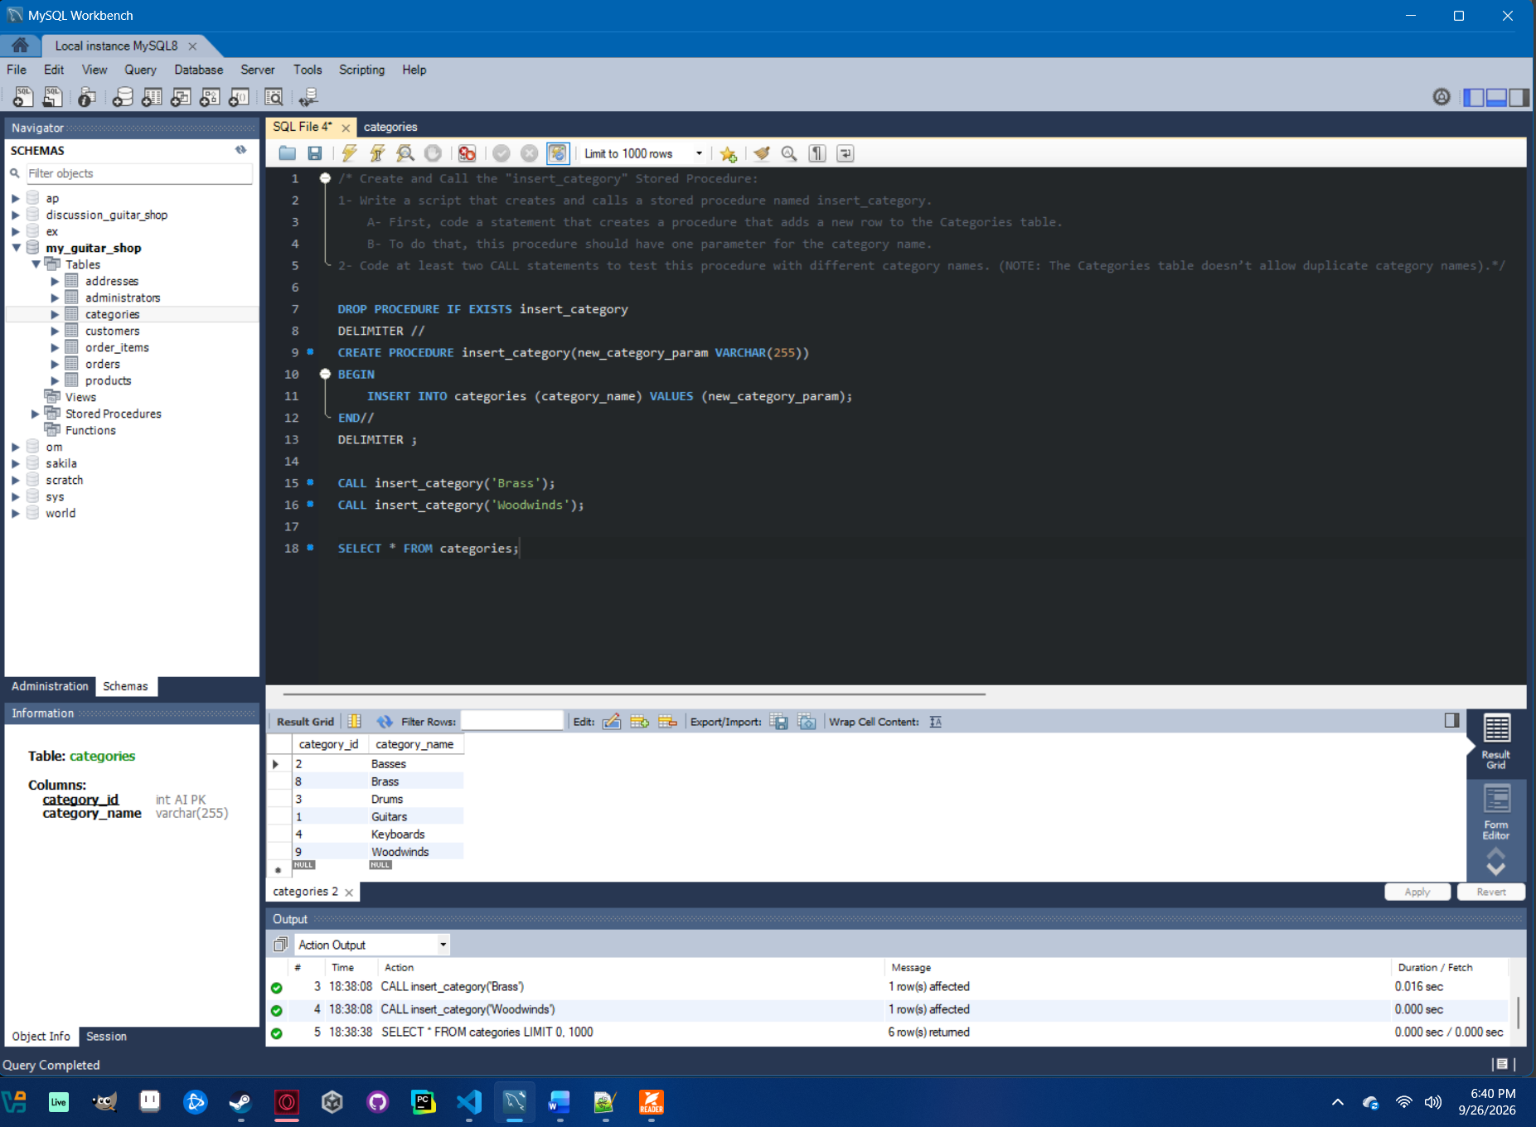

Task 2.3 - Create and Call the "discount_price" Stored Function
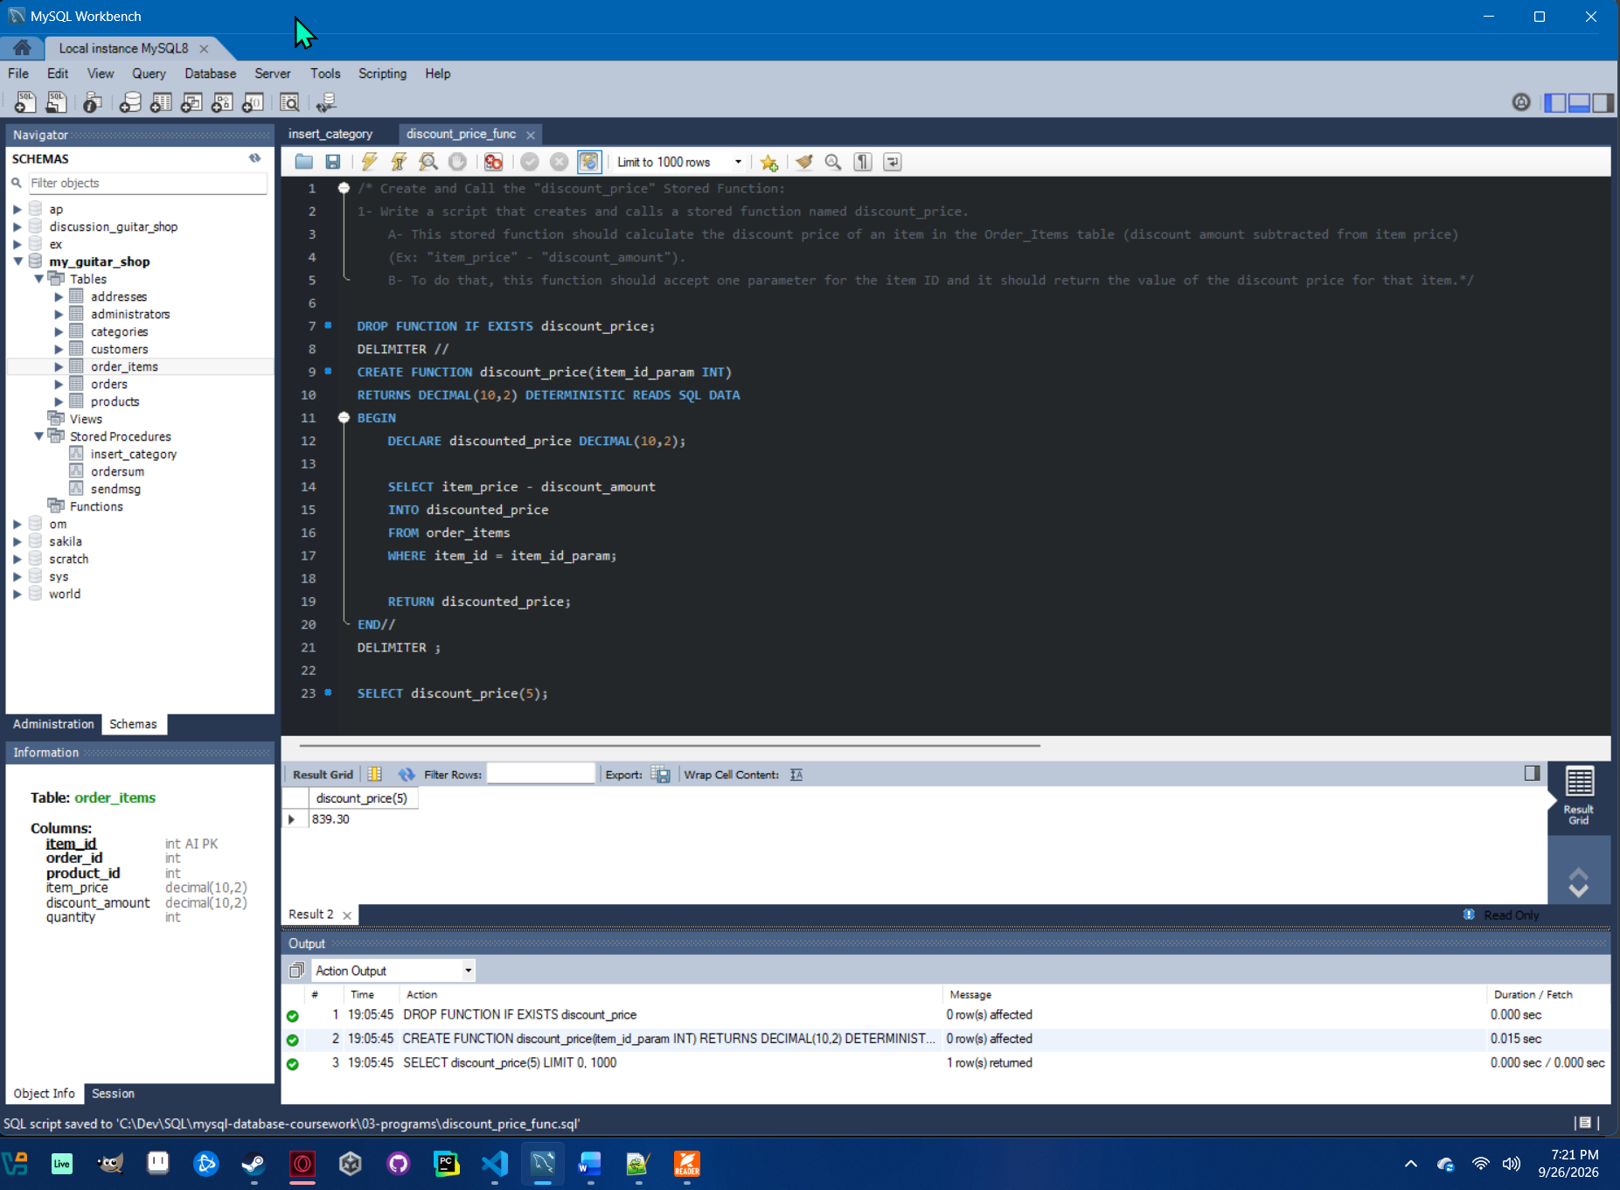

Task 3.3 - Create and Call the "item_total" Stored Function
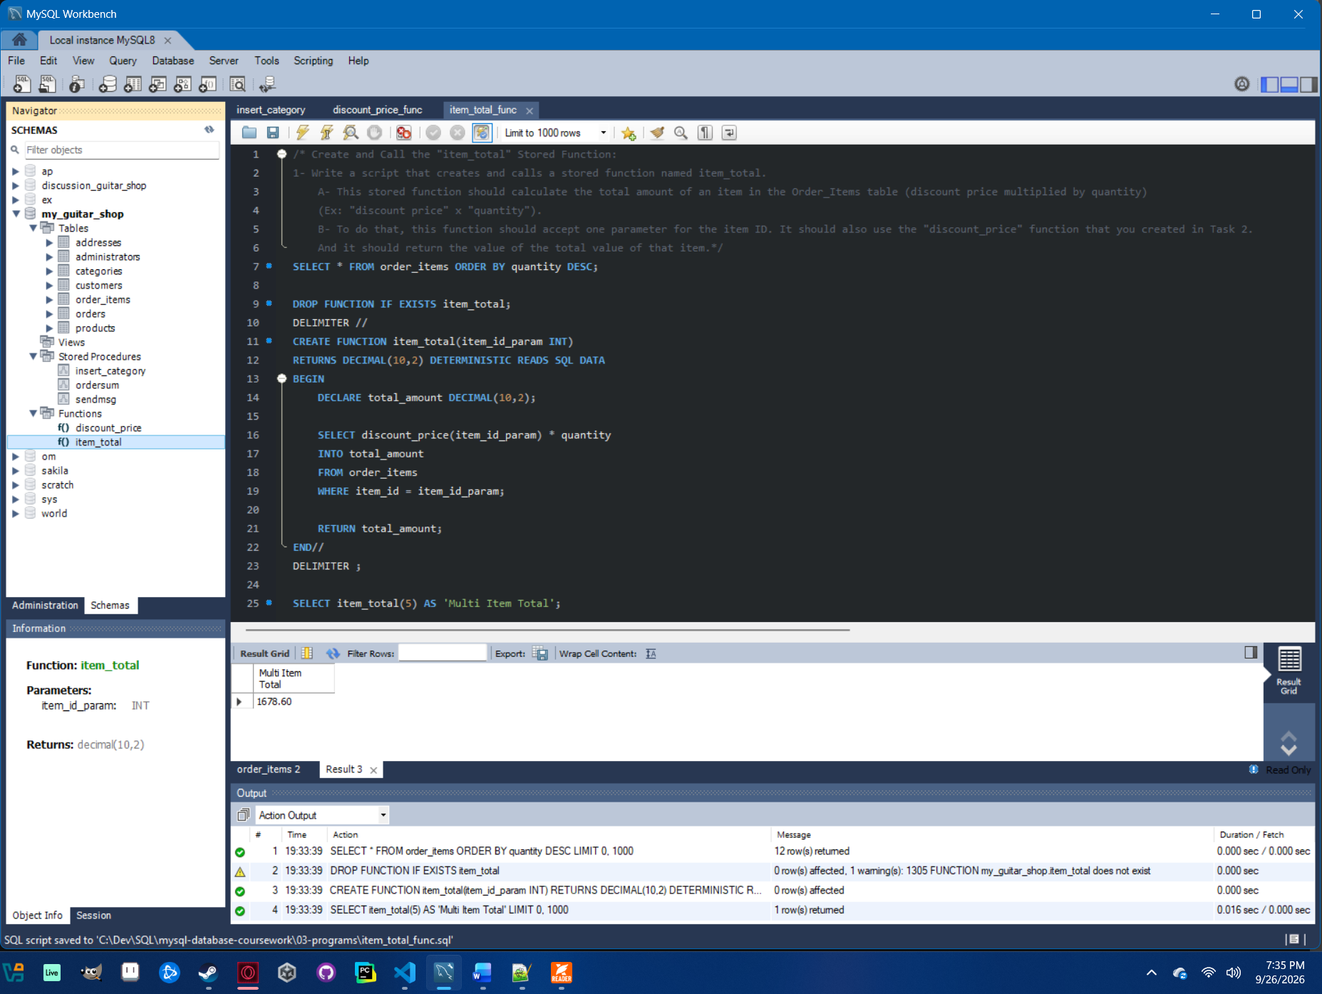

References

Murach, J. (2019). Murach’s MySQL (3rd ed.). Murach Books.

